Tess Byler, PG, CHG
Tess has been with the SFCJPA since 2016, and in that time has been a jack-of-all-trades to get project work done, from technical documents, stakeholder engagement and grant writing. She previously worked in environmental consulting, managing a team of 35. She serves as Subject Matter Expert for California hydrologeology, and enjoys volunteering with local entities, including Valley Water, Environmental Volunteers and the GCRCD.
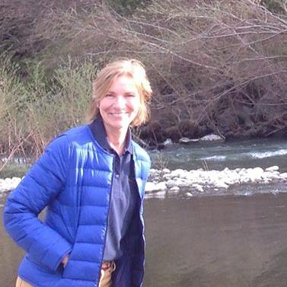
She is at home near the Creek, and enjoys biking in the Baylands almost every day.

